Clinical Definition

Student’s Name
Instructor’s Name
Course
Date

Clinical Definition
- Antibiotic
Anti-infection are types of antimicrobial substances that battle certain diseases and can save lives when utilized appropriately. The antibiotics slow down or destroy the growth of bacteria.
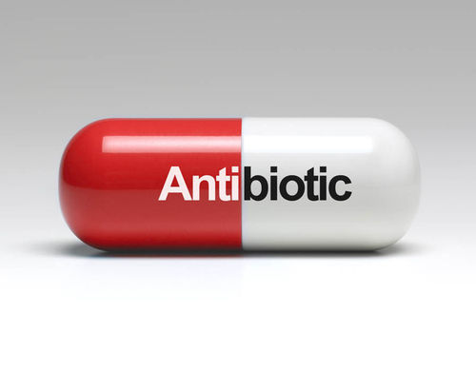
Fig 1.1 antibiotic (Bartlett et al.,2013)
- Cell
The cell is the basic layer-bound unit that contains the basic atoms of the daily routine of which all experiencing things are created. A cell can also be defined as the fundamental underlying and practical unit of any living thing.
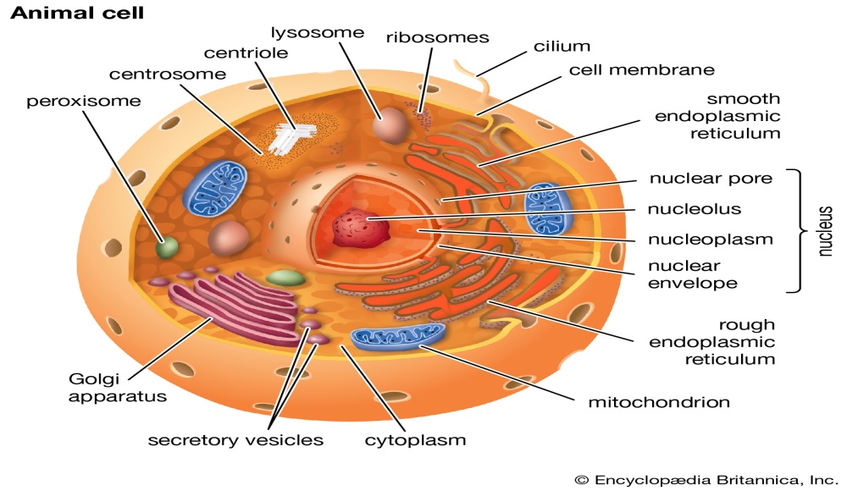
Fig. 1.2 animal cell (Butler, 2005)
- Host
The host is a creature from which a parasite gets its nourishment as well as a haven. The host can also be defined as a living being or cell culture in which an infection can recreate itself.
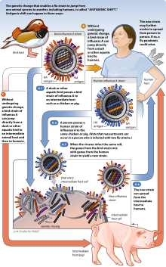
Fig 1.3 Hosts
- Virus
A virus is a more modest microorganism than a bacterium that can't develop or duplicate separated from the living cell. A virus keeps itself alive and replicates itself using the chemical machinery available in a living cell.
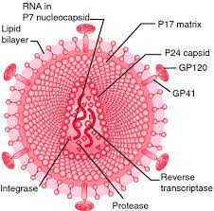
Fig 1.4 virus
- Superinfection
Superinfection is subsequent contamination superimposed on a previous one, particularly by an alternate microbial specialist of exogenous or endogenous root impervious to the treatment utilized against the primary disease.
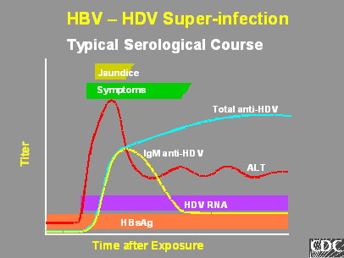
Fig 1.5 superinfection
- MRSA
MRSA stands for Methicillin-resistant Staphylococcus aureus, and it's an infection infecting various parts of the body and is resistant to some antibiotics.
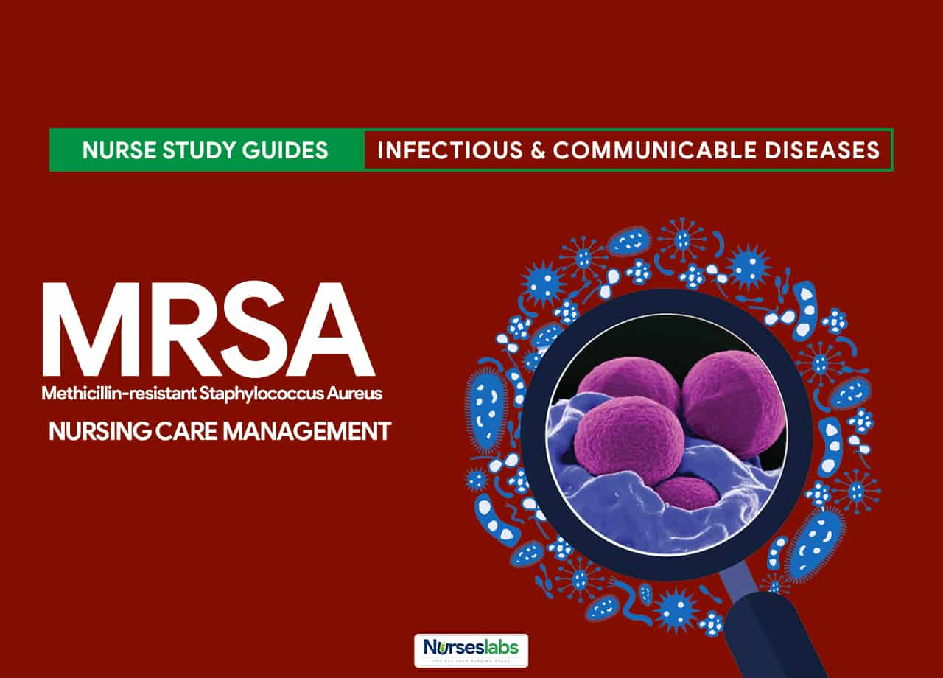
Fig 1.6 MRSA
- Acquired resistance
Acquired resistance happens when a specific microorganism acquires the capacity to oppose a specific antimicrobial specialist's movement to which it was beforehand powerless.
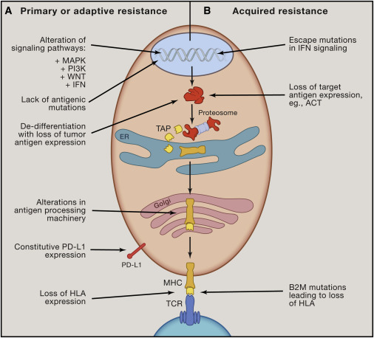
Fig 1.7 acquired resistance
- Bactericidal vs bacteriostatic
Bacteriostatic is an agent that keeps bacteria in a stationary phase and prevents bacteria's growth, while bactericidal implies that the agents kill the bacteria.
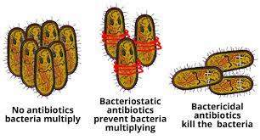
Fig 1.8 bacteriostatic vs bactericidal
- Antiviral
Antiviral is a specialist that slaughters a virus or smothers its capacity to repeat and, subsequently, restrains its ability to increase and recreate, for example, amantadine.
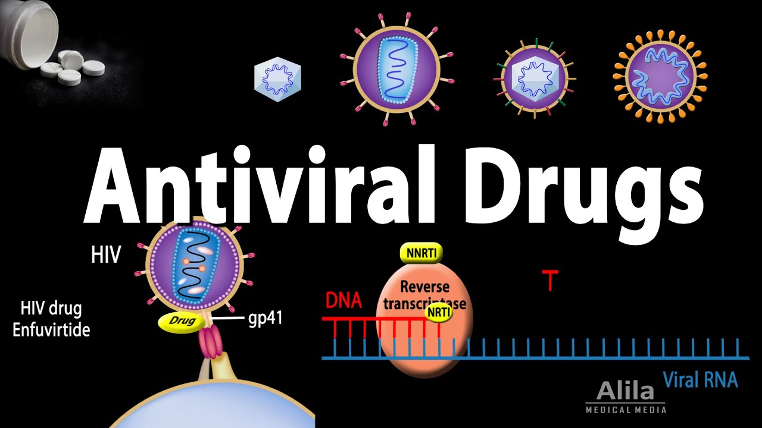
Fig 1.9 antiviral
- Retroviral
Retroviral is a type of virus that is contained in the RNA instead of DNA. Retroviruses have the unique property of transcribing the RNA into DNA after entering a cell, which they get from an enzyme called reverse transcriptase.
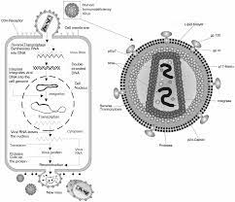
Fig 2.0 retrovirus
- HIV
HIV is the human immunodeficiency virus that attacks the body's defensive system. HIV causes AIDS if it is not treated.
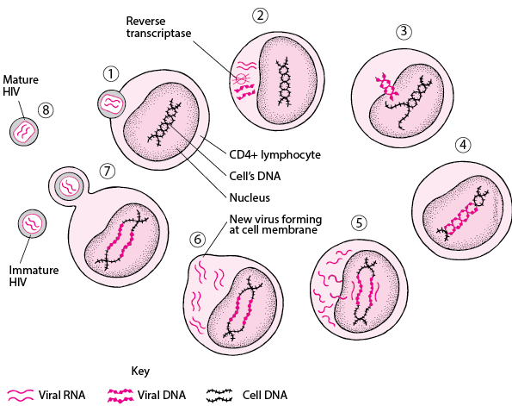
Fig 2.1 HIV
- HAART
HAART is a form of medicine routine utilized in administering and treating human immunodeficiency infection of type 1. The treatment utilizes more than three combinations of drugs. 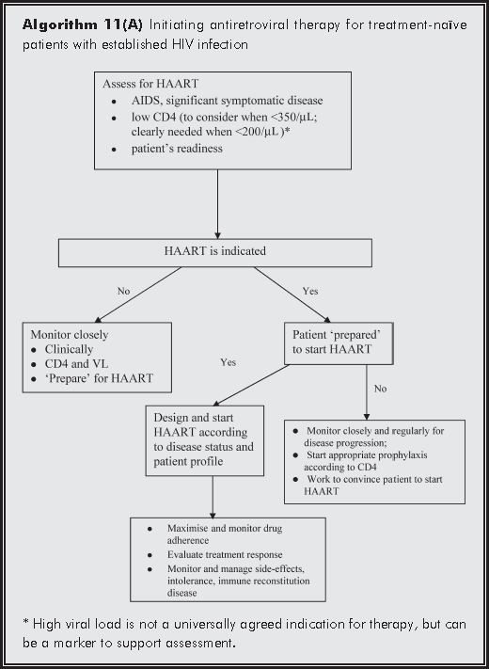
Fig 2.2 HAART
- HPV
HPV is a virus that can cause unusual tissue development and different changes to cells, such as moles. Cervical cancer can develop from the infection of HPV for a long time in certain types of people.
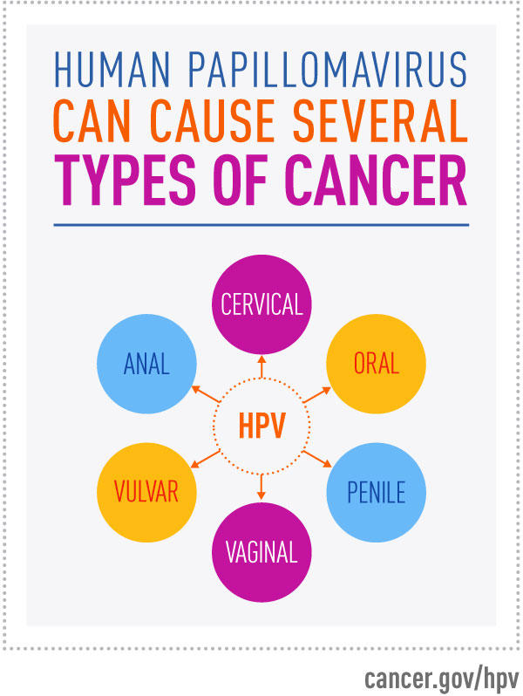
Fig 2.3 HPV
- Herpes
A family of viruses is known as Herpes. Herpes can also be defined as elude to diseases with one of the human herpesviruses, particularly herpes simplex of sorts 1 and 2.
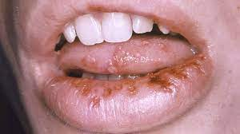
Fig 2.4 herpes
- Influenza
The attack on your respiratory system, throat, nose, and lungs caused by a viral infection is known as influenza. It is commonly known to affect the upper respiratory.
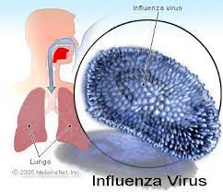
Fig 2.5 influenza
- Covid
The occurrence of any of the three or more of the following symptoms; cough, fever, headache, fatigue1, myalgia, diarrhea, sore throat, and nausea is known as Covid.
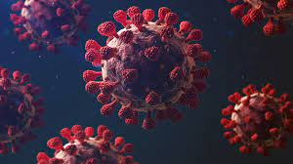
Fig 2.6 Covid (Rolland et al.,2008)
- Hepatitis
Inflammation of the liver is known as Hepatitis. The irritation is growing that occurs when tissues of the body are contaminated or harmed. Hepatitis can be a short-term or long-term infection damaging your liver.
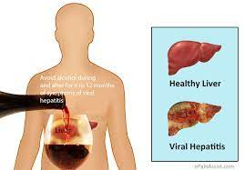
Fig 2.7 hepatitis (World Health Organization, 2017)

References
Spellberg, B., Bartlett, J. G., & Gilbert, D. N. (2013). The future of antibiotics and resistance. New England Journal of Medicine, 368(4), 299-302.
Butler, M. (2005). Animal cell cultures: recent achievements and perspectives in the production of biopharmaceuticals. Applied microbiology and biotechnology, 68(3), 283-291.
World Health Organization. (2017). Global hepatitis report 2017. World Health Organization.
Van Kan, G. A., Rolland, Y. M., Morley, J. E., & Vellas, B. (2008). Frailty: toward a clinical definition. Journal of the American Medical Directors Association, 9(2), 71-72.

